Watch out for ticks!
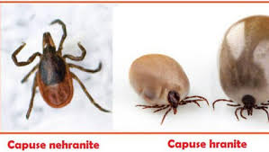
- The warm season and the outdoors are accompanied by the appearance of tick bites
- If you have discovered the tick attached to the skin, you must go to a medical unit (family doctor, permanent center, infectious diseases office, specialist outpatient clinic)
- The tick is removed with a special forceps 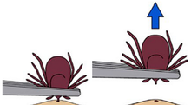
- The pricked area will be monitored for 1 month
- If there is a local reaction (redness, erythema) it will be presented to the family doctor, who will determine the need to send for a consultation to the Infectious diseases Department
- Depending on the appearance of the rash, antibiotic treatment measures and specific investigations will be taken
- We emphasize that not all ticks, but only a percentage of 10-20% can be carriers of the bacterium Borrelia Burdorferi, which causes Lyme Disease

How to prevent the tick bites
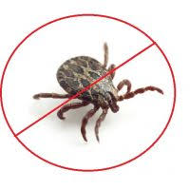
- Are to be avoided areas with grass and trees
- Wear light-colored clothing to cover exposed areas when walking in nature
- Apply repellent spray
- Check back home carefully (also valid for pets)
- Protect pets from fleas and ticks

